*PX Line Laser Marking – New Barcode System Application*

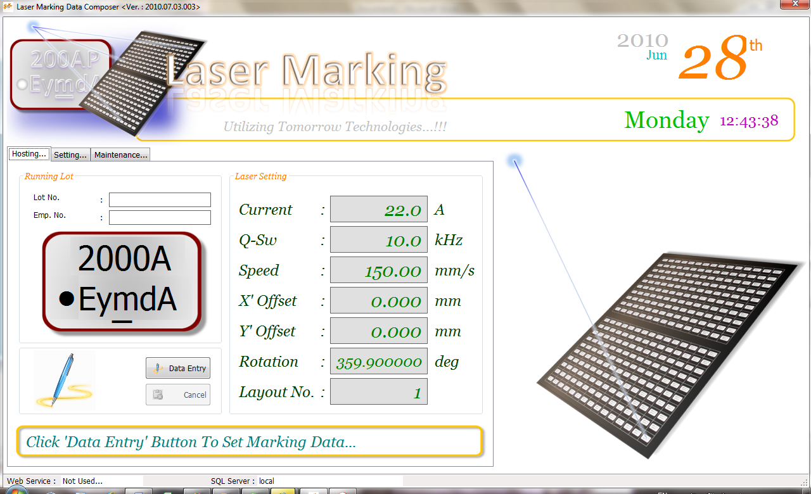**The packages includes the following files,**

1. Marking.mdb
2. ActiveProc.exe
3. D0159999.dat

**The package also comes with a folder (Marking File) which contains,**

1. Layout011.inf
2. Layout011.lfd
3. Layout011.lmb
4. Layout011.los
5. Layout011.txt

Prior to the installation, please be confirmed that your system meet the following requirement.

1. Minimum 128 Mbytes RAM
2. Under Windows 2000, Dot Net Framework 2.0 is required.
3. Under Windows XP and Windows 7, Do Net Framework 3.5 is required.

Due to the setup program for Dot Net Framework is extremely huge in size. Please consult I.T. department for the installation.

Please follow the instruction below carefully to complete the setup successfully.

1. Copy the files ‘Marking.mdb’ and ‘ActiveProc.exe’ and paste into any folder you wish, example ‘C:\ActiveProc’
2. Copy all the files in the ‘Marking File’ folder into the ‘C:\Program Files\EXEC\Data’ Folder. This is the folder Miyachi ‘s LMDRAW application located.
3. You must register the new layout into the Laser Maker ML-7111A using LMDRAW application. Please refer back to my previous note for doing this.
4. Please remember to which Layout No you registered the ***Layout011*** layout.
5. Under Windows Explorer, browse to the location where ‘ActiveProc.exe’ was copied.
6. 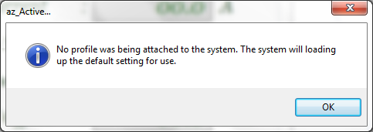Double clicking the file. The application will start loading. You may notice a message box pop-up as below. This is because the program is first run on the machine and it is look for preset database.
7. Click the ‘OK’ button. The application prompts you to key in the Machine Control No. In ETMY, the machine control number start with a character ‘M’ follow by 5 digits number (M00001). Perhaps, for ETTH, please follow the similar concept which the Control Number could not be more than 12 characters. Press ‘Enter’ to continue after the control number has been key-in.

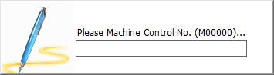

1. The Application will start backing up all the parameter setting and IMI file into the application database. In ETMY, the database is at the server. However, this Application running as a standalone application for ETTH. As such, the ‘*Marking.mdb*’ was used and it must be located at the application folder.
2. 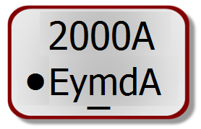To make a new marking pattern such as the following. A profile parameter needed to be set.
3. We are making the Barcode system more flexible and user friendly. The previous version support limited Marking Block. Figure below shown the main interface of the application.

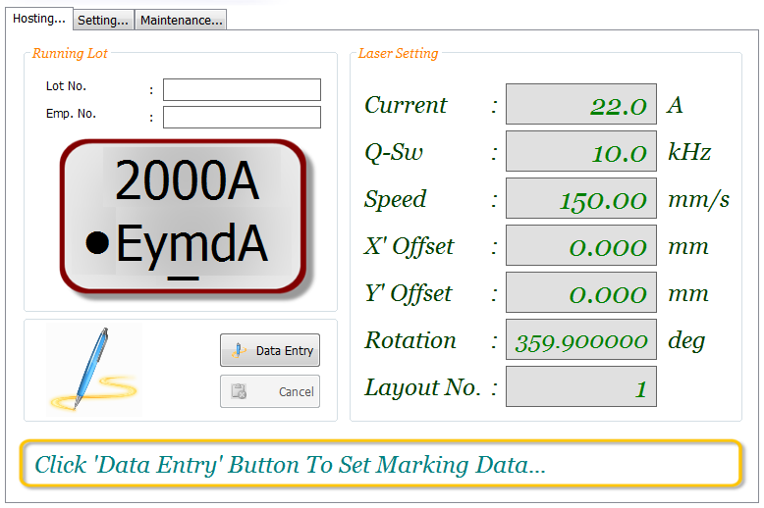

1. 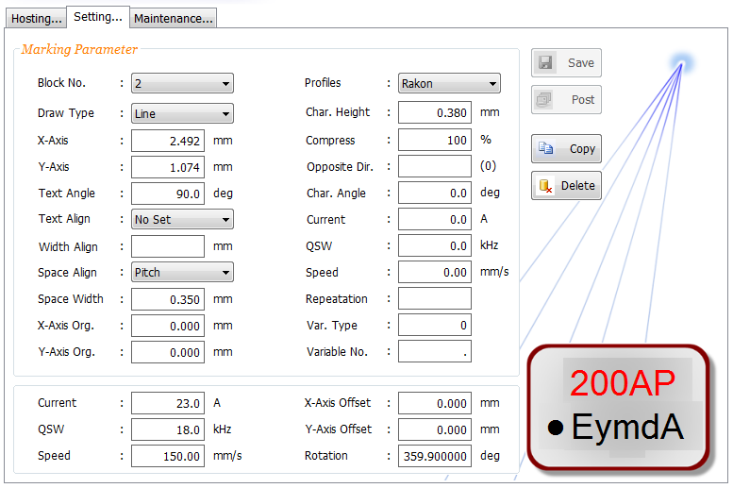Select the ‘Setting’ tab. The application will prompt you an access password. Enter the password ‘*azActive*’ (follow exactly upper case and lower case as it is case-sensitive). The Editor screenshot is as shown below.

1

1. To make your job easier, it is recommended that you choose the ‘*Rakon*’ profile as shown in figure above. By scrolling through the Block (refer figure above), the diagram illustrated the current selected block.
2. Since the ‘*Rakon*’ profile is near to the newer product marking pattern. So, let copy the entire profile to make a new one.
3. Upon select the ‘*Rakon*’ profile, press the ‘Copy’ button to make a copy of the selected profile. Follow the instruction prompt by the wizard to complete the copy process.

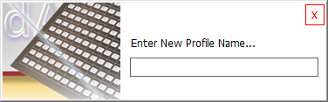

1. Please note that, the Layout No. is the number you registered the new layout using the LMDRAW application.
2. 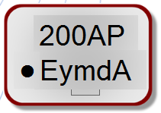The new profile will be selected automatically. Now, select Block No. 4. You may notice a blinking mark as shown in the figure below.
3. 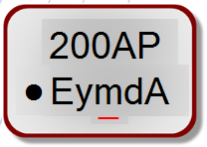Now, move the computer mouse near to the blinking area and then double clicking on it. A line mark will immediate appear.
4. Click the ‘Save’ button to save the changes. Now, the barcode system is ready for the new marking pattern.
5. Last but not least, copy the ‘***D0159999.dat***’ into the application folder under ‘*\Data\IMI*’. Rename the filename according to the IMI No.
6. You will need to edit the text file as descript as the following.

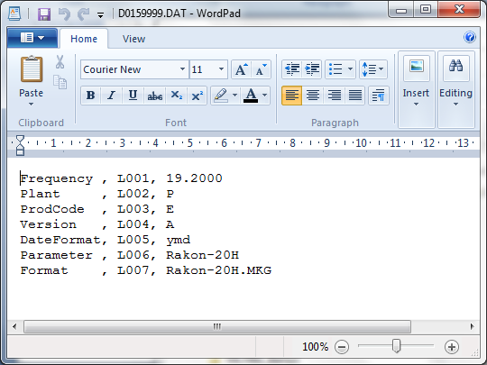

2

1

3

4

6

5

7

1. Set the frequency value. To avoid marking frequency value, set it to ‘0’.
2. Set the Plant code, Product Code and Version according to the IMI.
3. Set the date format to ‘*ww*’ for week number marking.
4. Set the Parameter and Format as according to the profile name set in the Barcode system. This is where the system communicates with IMI files.
5. 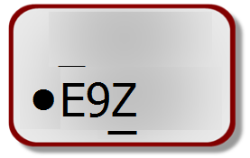Save all the changes you have done.

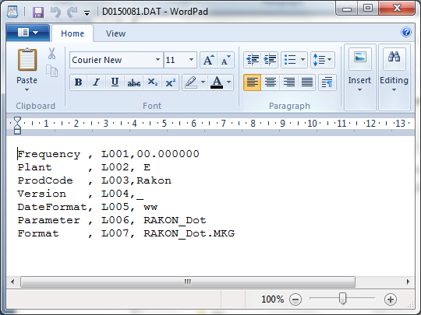

In order to make the marking as shown in the above, set the IMI files just as shown in the figure.

You have almost done! The very last thing to do is the final adjustment. You need to adjust X and Y position by using the barcode system’s editor. You will have to do a lot of marking test in order to achieve the target pattern. To do the adjustment, figure below shown all the area that need to be tune.



That’s all for the setup. All the best! And thanks for your full support!

By : Zulhisham Tan